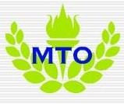
MTVII Invitation | December 27  2009
Congratulations! You have been invited to Madden Tournament VII. Enclosed is an information packet of anything you need to know. For any other questions don’t hesitate to check out our website at MTO.yolasite.com, or even ask the commissioner or members of the MTO Council. |  | MTVII

Madden Tournament Info Page
MTO was founded back in October of 2007 as a small tournament.
Madden Tournament I (MTI)
This was the first ever tournament that consisted of a triple elimination bracket, lasted a total of three hours, and only had madden. Of course, we found out that night 3 hours was not even close to enough time for a madden tournament.
Madden Tournament II (MTII)
This tournament was one month after the first and was better prepared for taking up the whole day and through the night.
Madden Tournament III (MTIII)
This was the first tournament with different games added to the schedule, but it continued the triple elimination tradition. This was in February of 2008. MTIII was the first tournament to implement the use of bracketmaker.com into our organization, which we still use today for our brackets.
Madden Tournament IV (MTIV)
MTIV brought the beginning of documentation to the Madden Tournaments with MySpace. This would later prove to be too unstable and inaccessible to continue its use.
Madden Tournament V (MTV)
MTV was in its setup just near an exact replica of MTIV. Few things were changed, this was more of a stabilization tournament to settle down the nonstop growth experienced from the beginning of the tournaments.
Andrew’s Madden Tournament I (AMTI)
This was the first tournament to be done outside of the original MTO organization. Stats were not ever prepared for this, but it was a monumental step of branching out. This tournament was run slightly different than the originals with a round robin type schedule for NHL before the playoffs were started. Andrew also set up the first online MTO rumor mill which is still the number one place for MTO rumors in the world. We are expecting more tournaments outside the organization’s original home soon.
Madden Tournament VI (MTVI)
Madden Tournament VI experienced the greatest growth with the addition of the official website through yola (mto.yolasite.com). Also, wild card games were introduced. These games are single elimination tournaments which were to consist of only 8-12 players the games would be nominated by the people. With the big elimination of triple elimination tournaments and the deletion of Halo and Mario Kart the tournaments were made more stable. Also, NHL was solidified as a constant never to be eliminated double elimination tournament. The Madden League was created for this tournament which consisted of a 10 game schedule followed by playoffs for the top six qualifying participants with the winner receiving the Bailey Trophy. With the addition of the website symbols were also created for the Madden Tournament itself, the Superbowls, and the Stanley Cups.
Madden Tournament VII (MTVII)
This is by far the biggest tournament ever prepared. There are many preparations going on for this tournament right now, but today never before released information will be submitted. The first most obvious addition to MTO is our release of the official symbol. Second, we have now created a MTO Council to help make sure each decision that goes through is for the benefit of the party. (For more info on the MTO Council visit the Official MTO Council webpage on our website.) Also, the Suggestions for Additions webpage was added where you can voice your opinion on what you think needs changed and the council will decide if it is valid enough to go through with. Another webpage added is the Trading Block which further stabilizes MTO trading status where you can now offer up trades to each other and post who you are willing to trade and what you would like in return eg. Pat Williams for Halfback worth 84 and above and you are allowed to trade draft picks once the draft order is announce. You can expect that announcement on November 13th. The biggest addition you will notice is the addition of a Fantasy Draft. On December 27 Andrew will be hosting the fantasy draft for the Madden League. It will be a couple hours long. In these hours we will have every game that is to be at MTVII there for people to play as well as other activities yet to be decided. Everybody is invited even if you don’t plan on being in the draft you can still play the games. It will go through the night for those that wish to stay we will set up a few quick four person tournaments, along with trying out a few different games to get the feel of them; there will be plenty to do. T-shirt and Hoody orders are also now available, for anyone interested. Today, I would like to announce that on December 27 we, the commissioner and the MTO council, will be holding a press conference where any questions will be answered including the official date of MTVII.
The Future
MTO’s goal is to hold at least three more tournaments after this next one and continue to grow into an increasingly stable organization. We eventually hope to branch away from yola onto a free reigning website of our own. Our greatest aspiration at MTO is to reach the pinnacle of our success by MTX. We wish everyone good luck in the upcoming tournament and to not forget to check out our official website at MTO.yolasite.com

MTO Commissioner
Brett Ball
Brett Ball
The First Event
Visit our website for more information at http://mto.yolasite.com
Madden Tournament VII Invite
Who: You
What: Madden Tournament VII Fantasy Draft
When: Sunday, December 27, 2009 after WAHS Basketball Practice
Where: Andrew’s House-445 Phillips St. Warren, PA
The Second Event
Who: You
What: Madden Tournament VII
When: TBA 2010 (Will be announced during Press Conference on December 27th, 2009)
Where: Brett’s House - 11 Tall Pines blvd. Warren, PA
Visit our website for more information at http://mto.yolasite.com
Form due by February 13, 2010
Madden Tournament VII
R.S.V.P. Form

.
First Name Last Name

. Cell
Phone Number Home

.

Message: .
.
.
.
.
.
Will you be at Madden Tournament VII? Yes No

.
Signature Date
Visit our website for more information at http://mto.yolasite.com

Madden Tournament VII Fantasy Draft Team Creation Form

Form due by January 15, 2010
__________________________________________________________
First Name Last Name

City of team State of team Team Name
(City name is first part of team name)

Team Logo Team Logo:____________________________
- Atomic
- Baboons Primary Color:_____________________________
- Bandits
- Bulldogs Secondary Color____________________________
Visit our website for more information at http://mto.yolasite.com
- Centurions
- Crocs
- Demons
- Sharks
- Hawks
- Heat Wave
- Killer Bees
- Meteors
- Phoenix
- Rhinos
- Siege
- Shamrocks
- Islanders
- Vipers
- Warthogs

Signature Date
Form due by December 15, 2009
Madden Tournament VII Fantasy Draft R.S.V.P.

Last Name First Name Phone Number
Home
Cell

Yes No Will you be at the Fantasy Draft?
Yes No Will you be participating in the draft?

Message:_______________________________________________________________________________________________________________________________________________________________________________________________________________________________

Signature Date
Visit our website for more information at http://mto.yolasite.com
Form due by December 1, 2009
Clothing Order Form

These are just T-Shirt and Hoody order forms for anybody that wants to buy one, below are pictures of the front and back of the shirts and Hoodies.
T-Shirts are $20.00
Hoodies are $28.00
Item | Size | Amount | Size | Amount | Total Cost
T-Shirt
Hoody
Totals
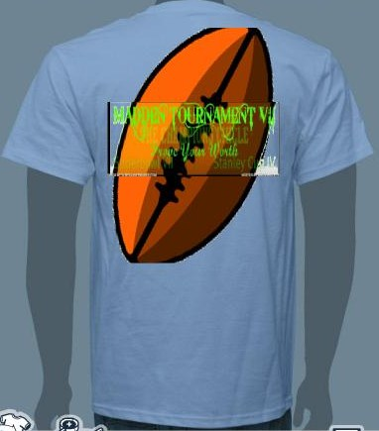
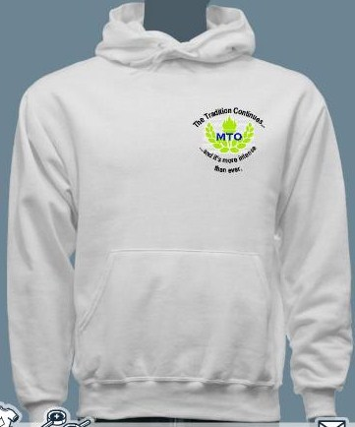
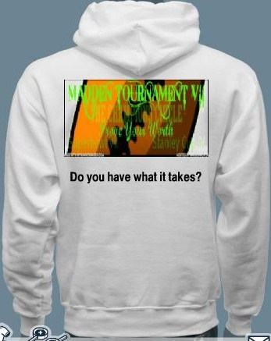
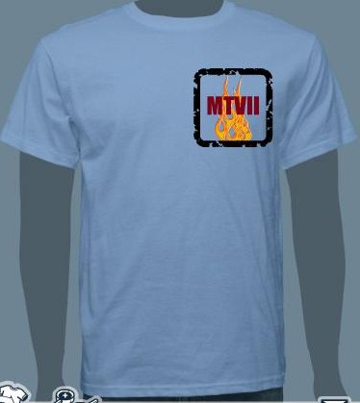

__________________________
Visit our website for more information at http://mto.yolasite.com
Signature Amount Enclosed Date

